Tutorial 3 – Aiden Burgess

Abur970

## Domain research

There are many applications on the app store for alarm clocks. Most phones also come pre-installed with a clock app containing alarm functionality. There are many ways to dismiss alarms: solving puzzles, shaking the phone, taking a specific photo. Notification is also another variable in alarms. Examples of notification methods are songs, podcasts, annoying sounds, vibration and popups. Further functionality is provided in some applications with the option of recurring alarms. Some are specialized for just sleeping, waking people up at the correct time in the sleep cycles. Reminders are a sort of specialized alarm for events. There are some apps which are extremely customizable allowing changes to snooze behaviour and notification behaviour.

## Partner work practice

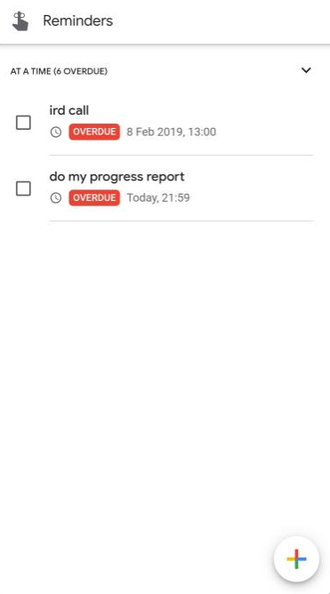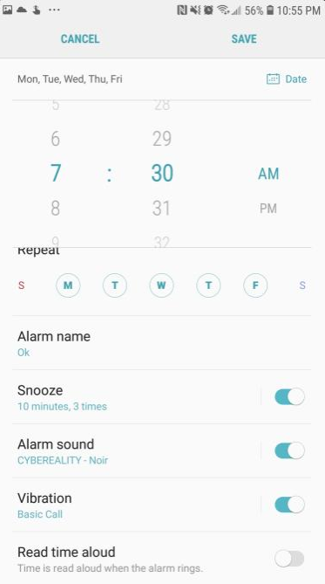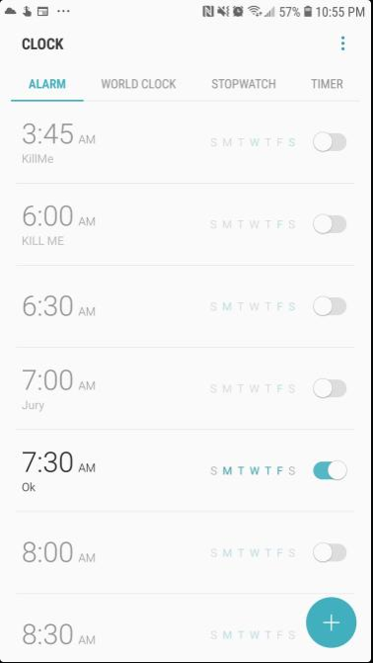My partner uses alarms on a regular basis. He does not use alarms outside of mobile. The main purpose of alarms in my partner’s lifestyle is help himself wake up on time. To do this he utilises a recurring alarm each week. The reason he needs to use an alarm is he finds it difficult to wake up.

Occasionally, he uses one-off alarms for exams and assignments. To motivate fast dismissal, he uses “annoying” music. The two applications that my partner uses for alarms are the google assistant (for reminders) and the default clock application. One frustration that my partner has found with both the applications is the absence of dark mode. As these applications are used in the early morning and late at night, the harsh bright light burns the eyes. He has only recently started using reminders app but plans to use it for university assignments. The phone is kept ten meters away from bed as another means to force getting up and turning off the alarm. The only options for recurring alarms are setting the weekly schedule, and this weekly schedule will repeat.